**START-UP CORNER**

**EXHIBITION SPACE RENTAL**

**To be returned to Hande Yilmaz by email** [**hyilmaz@estro.org**](mailto:hyilmaz@estro.org)

Bookings for spaces in the start-up corner are **open to start-up companies only** *(start-up: company which has been in business less than 5 years and has fewer than 10 employees)*

Please complete in capital letters. ESTRO cannot be responsible for mistakes resulting for illegible handwriting.

**COMPANY DETAILS**

Company name

Invoicing address

Contact person

VAT number (if applies)

Purchase order number - PO (if applies)

Tel

E-mail …………………………....

Company website ………………………....

**COMPANY DETAILS TO BE PUBLISHED IN THE CONFERENCE PROGRAMME BOOK (if different from above, please complete)**

Company name

Company Address

Contact person

Tel…………………………....

E-mail …………………………....

This application is legally binding for the exhibitor pending its acceptance in writing by the organiser.

**By signing this application form, you declare that you have read and accepted the ESTRO Rules and Regulations.**

Name: Title:

Signature: Date:

**BOOKING OF NETWORKING SPACE**

**Price per space: € 1,500**

The start-up package offered by ESTRO includes:

* One-sided light boxes*
* 1 table
* 2 chairs

*\*All the artwork files that will be displayed on the one-sided light boxes should be sent to* [*hyilmaz@estro.org*](mailto:hyilmaz@estro.org)*. The dimensions for the light boxes are: 100cm X 200cm*

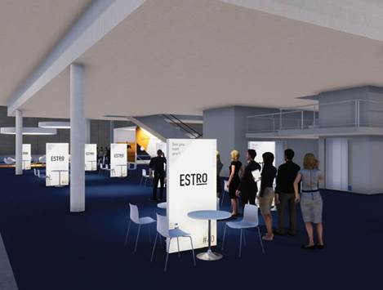

NOT included in the start-up package:

* Additional exhibitor orders
* Internet access
* Daily cleaning

We prefer the following booth locations: 1st .................. 2nd .................. 3rd..................